1100_CPP Enrollment initiated by EV for Residential Combo Customer
Contract No. 4017167955
Material No. 80010079
Serial No. 22690015
Equipment No. 100000427589
Contract Account. 100059434942
Functional Location. 6002276656

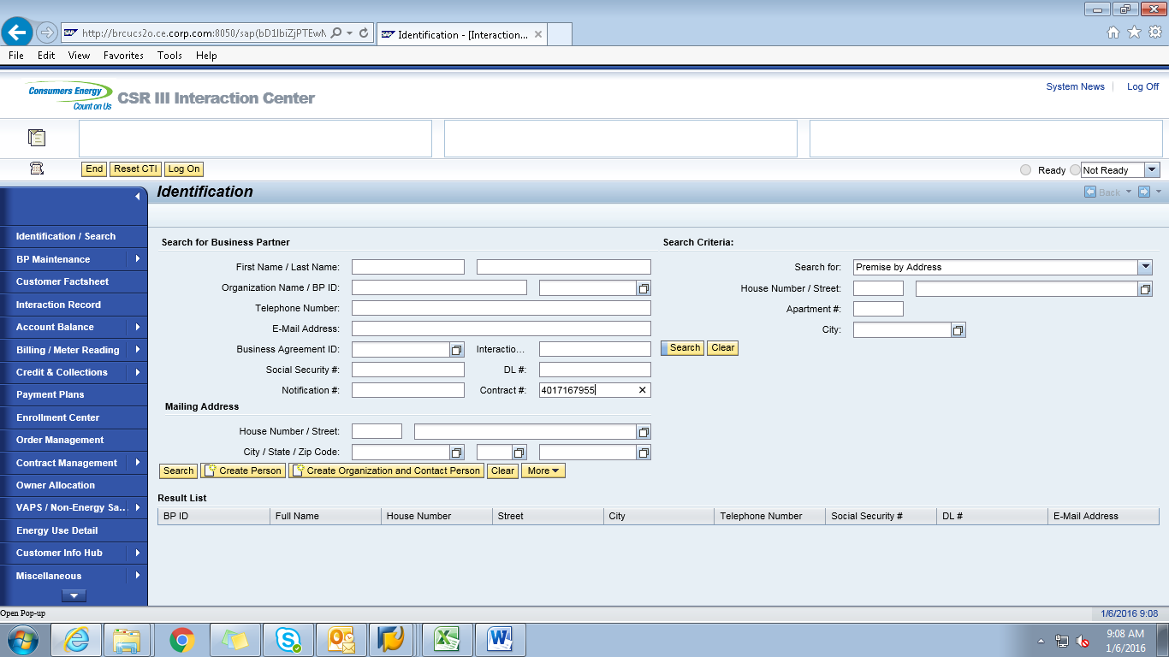

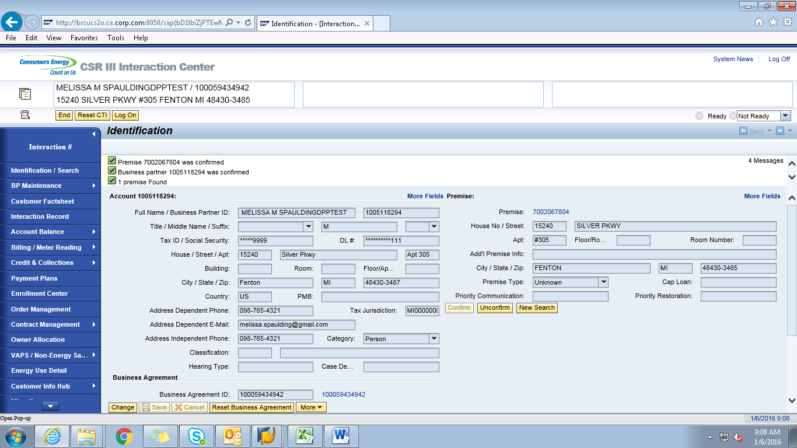

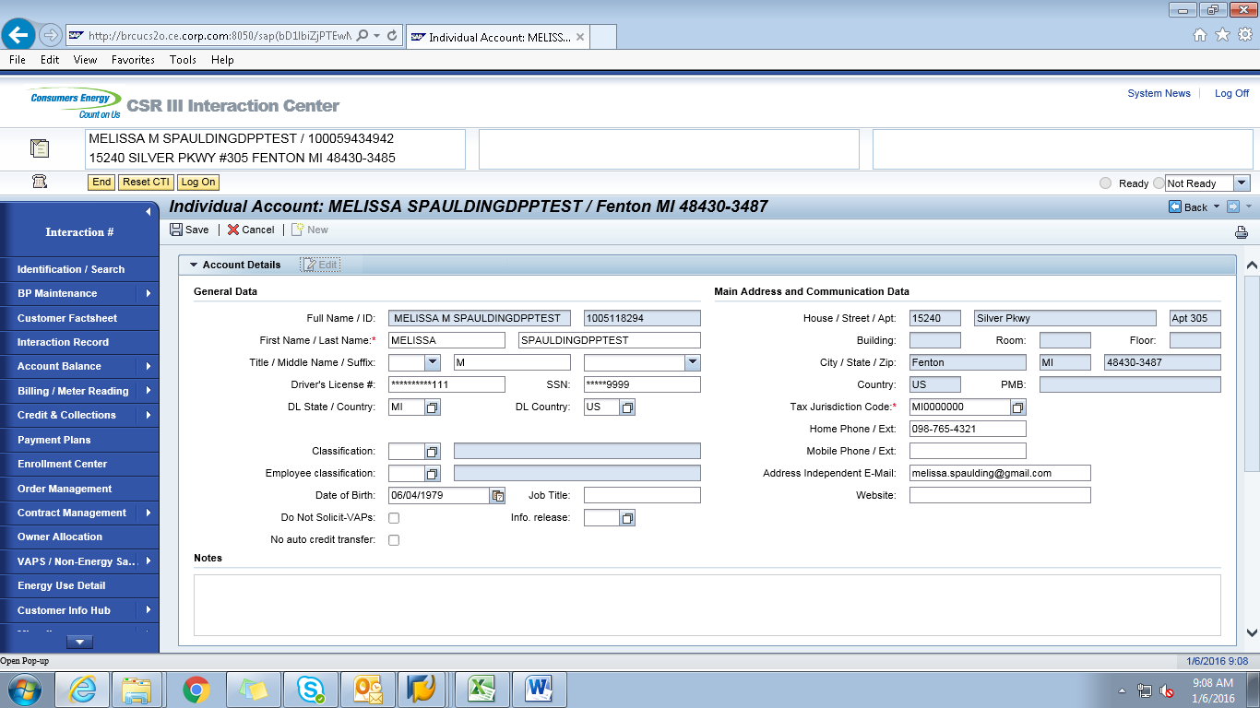

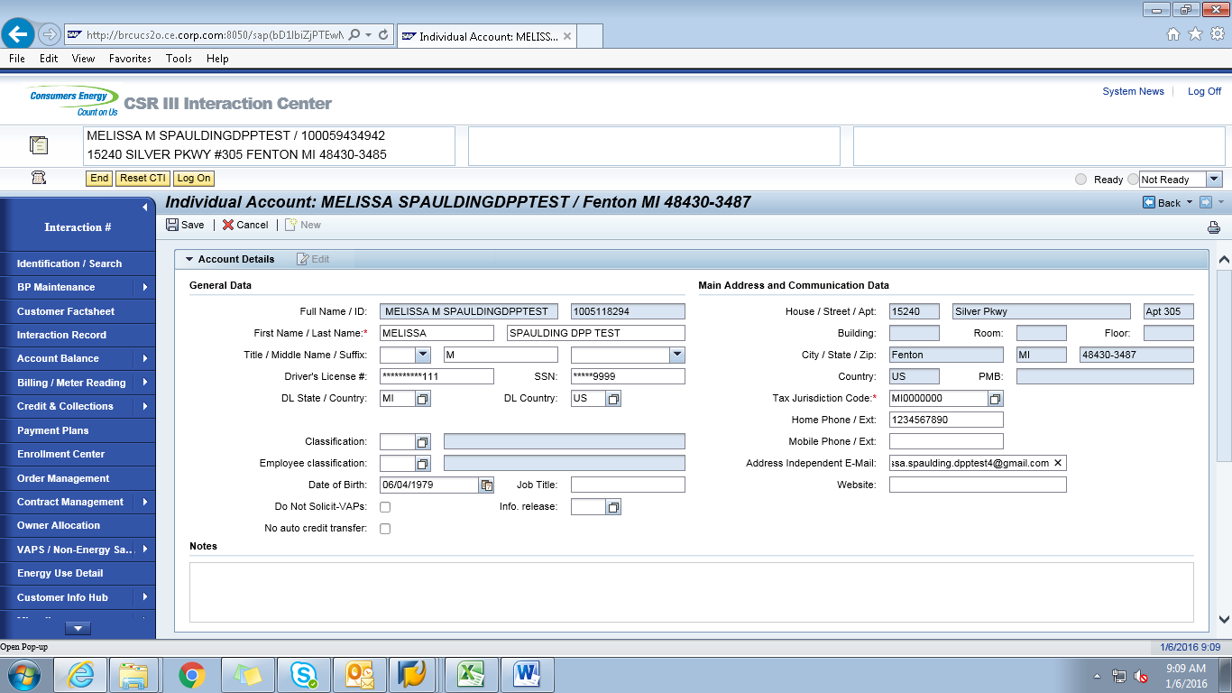

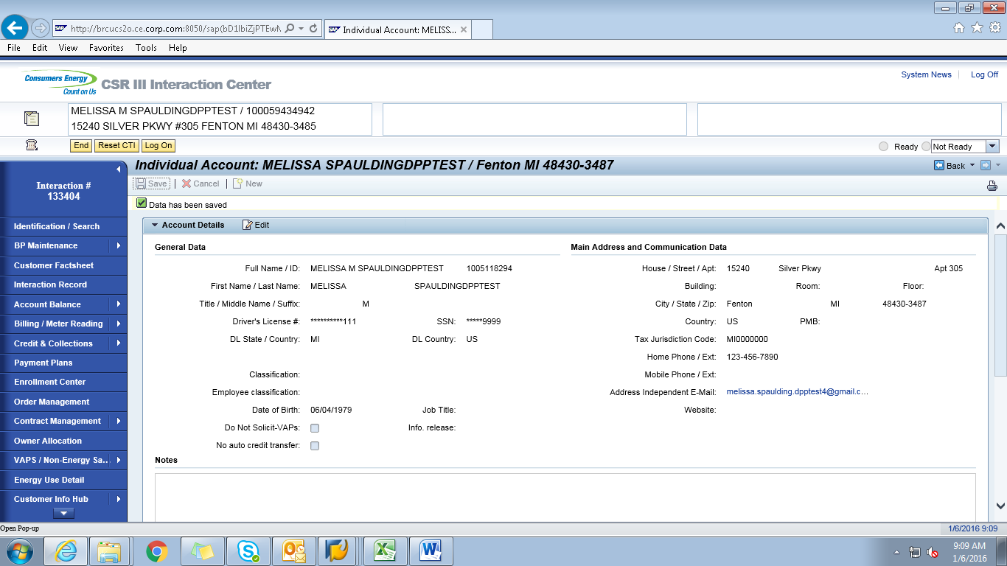

ECC
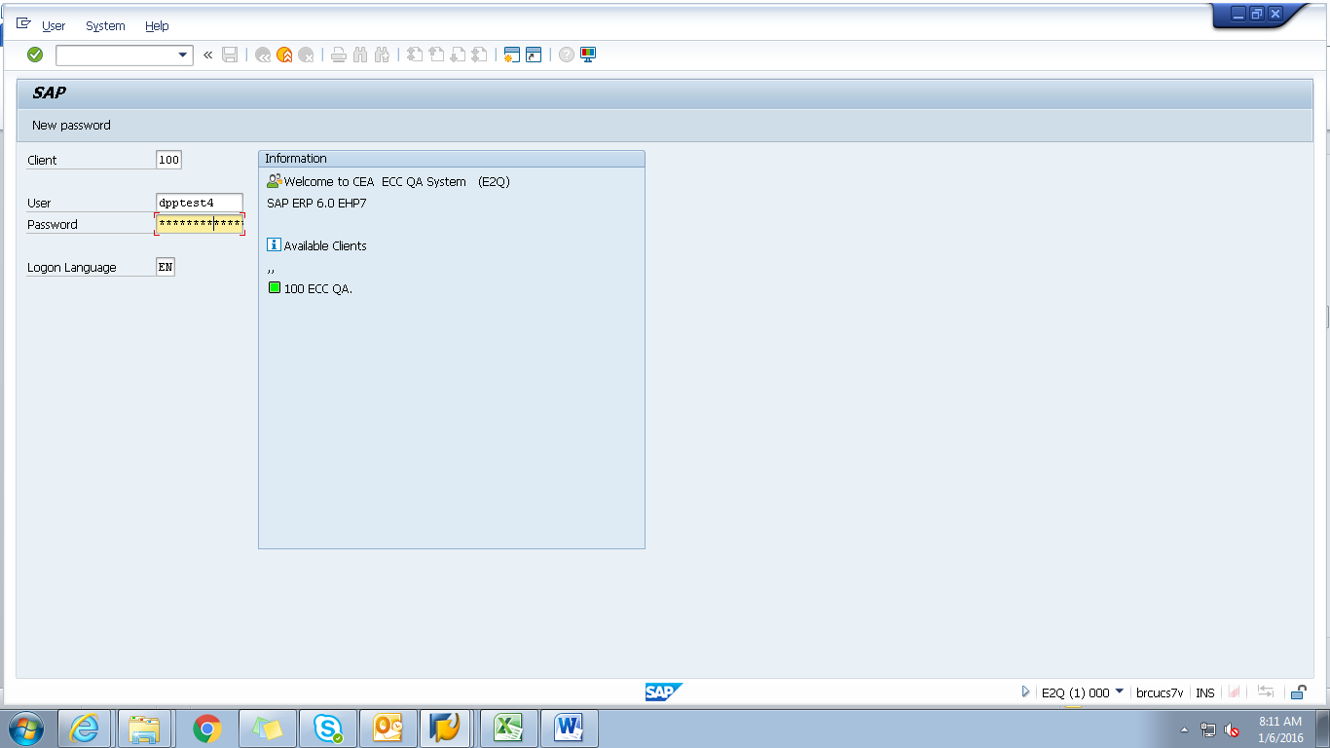
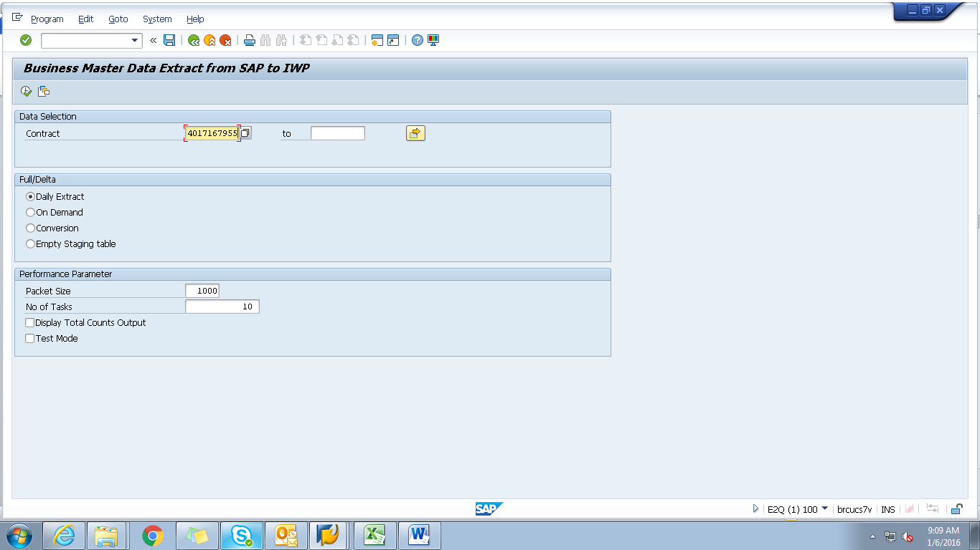

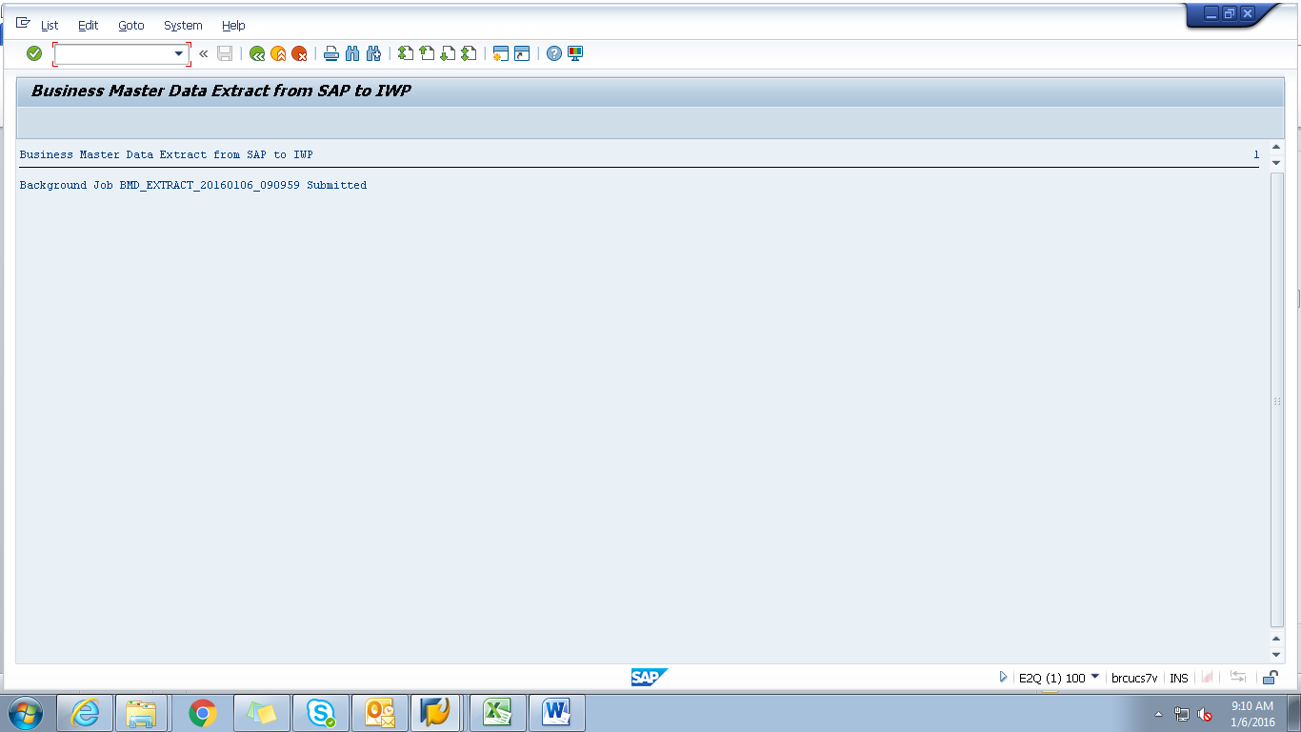

Obj tracking
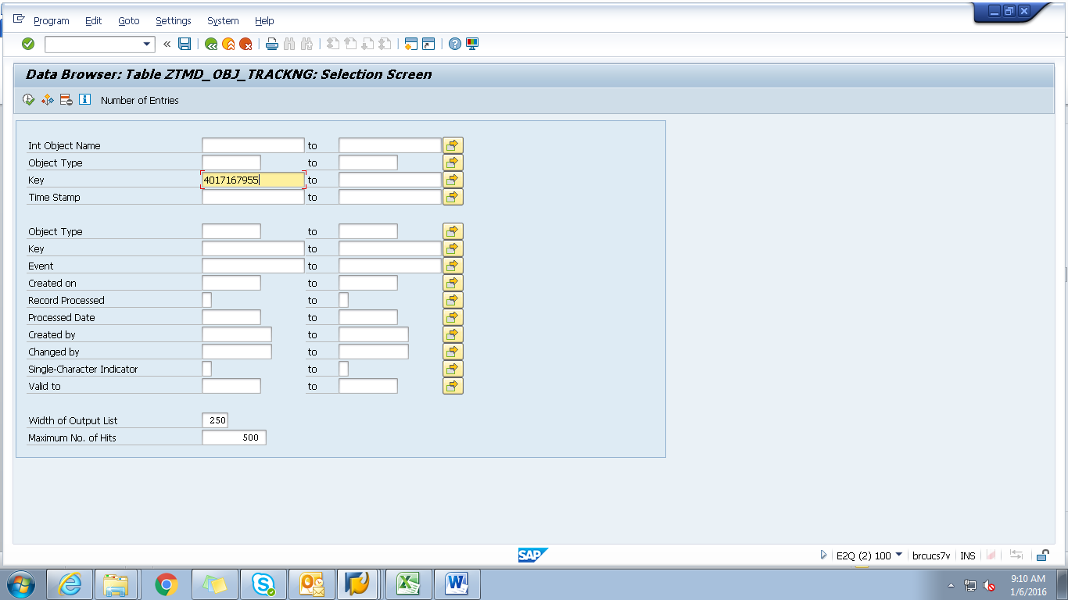

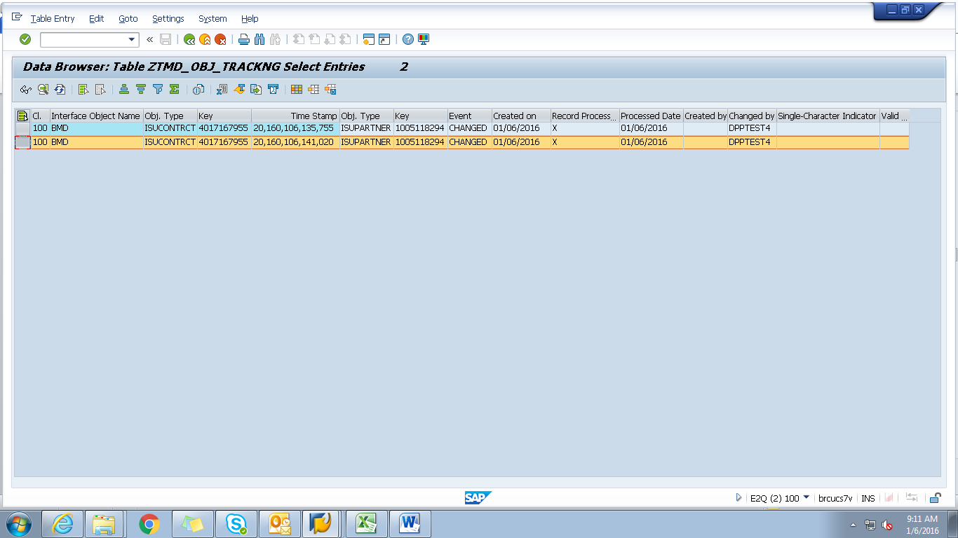

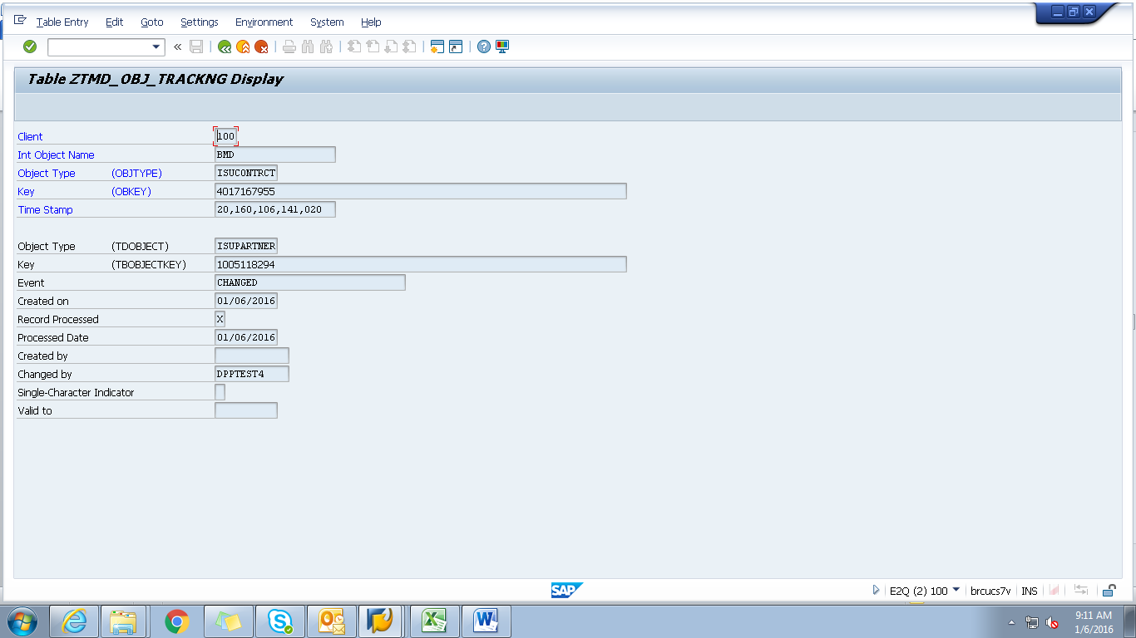

Spool
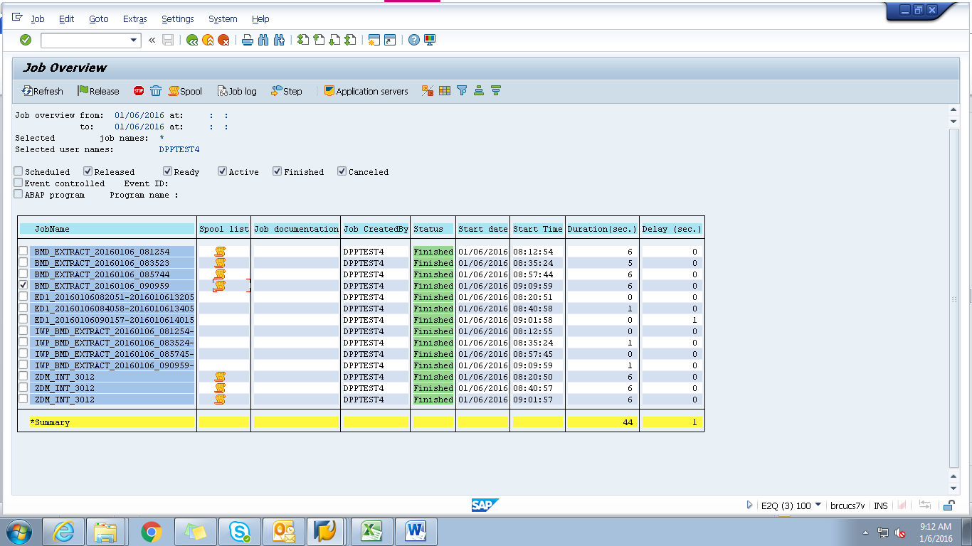

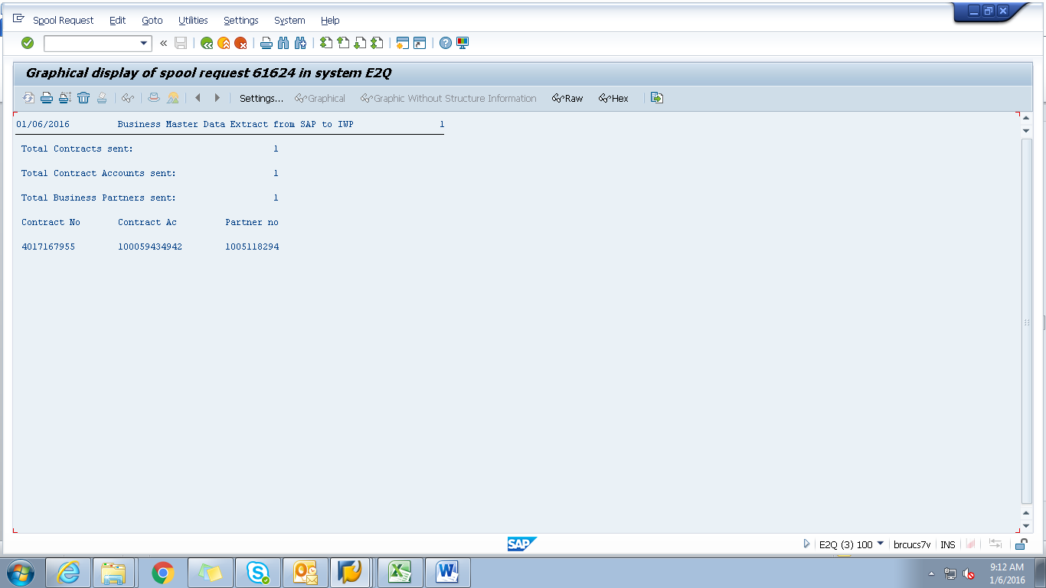

Payload
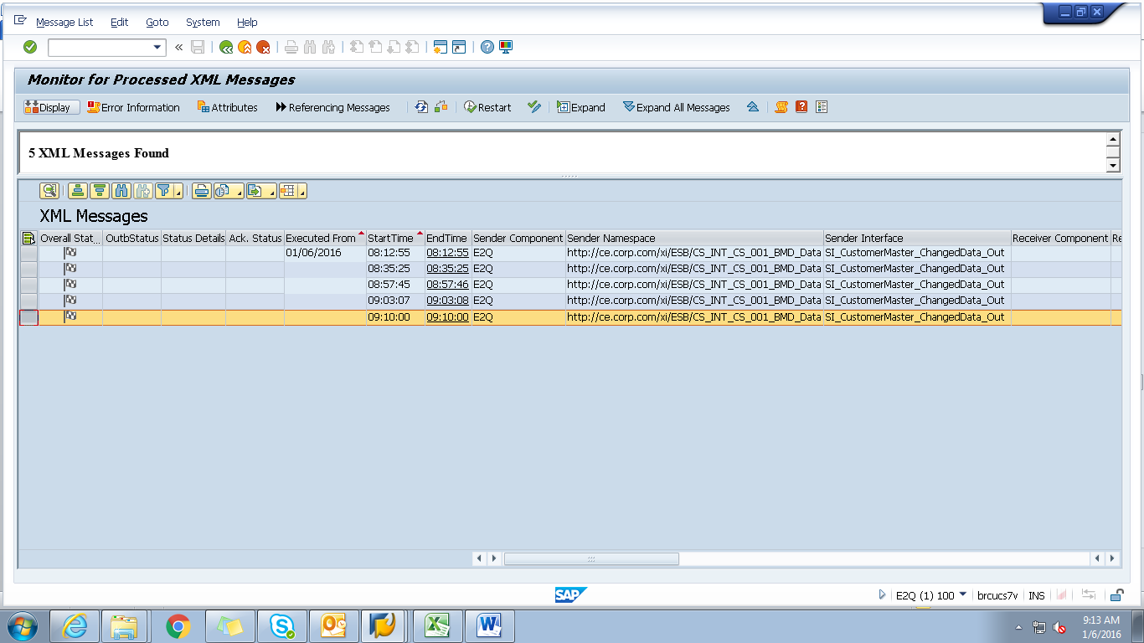

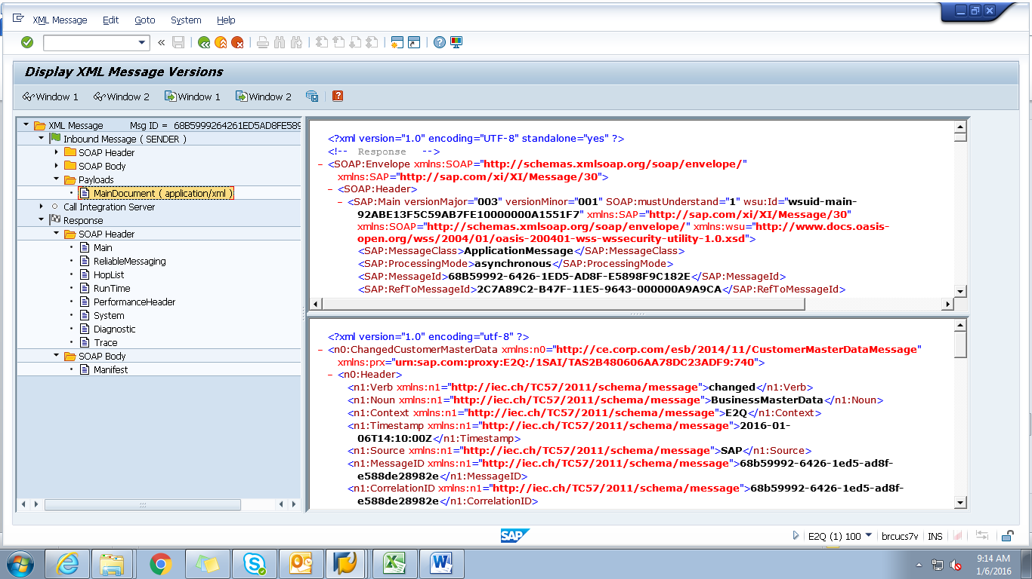

<?xml version="1.0" encoding="utf-8" ?>
- <n0:ChangedCustomerMasterData xmlns:n0="http://ce.corp.com/esb/2014/11/CustomerMasterDataMessage" xmlns:prx="urn:sap.com:proxy:E2Q:/1SAI/TAS2B480606AA78DC23ADF9:740">
- <n0:Header>
<n1:Verb xmlns:n1="http://iec.ch/TC57/2011/schema/message">changed</n1:Verb>
<n1:Noun xmlns:n1="http://iec.ch/TC57/2011/schema/message">BusinessMasterData</n1:Noun>
<n1:Context xmlns:n1="http://iec.ch/TC57/2011/schema/message">E2Q</n1:Context>
<n1:Timestamp xmlns:n1="http://iec.ch/TC57/2011/schema/message">2016-01-06T14:10:00Z</n1:Timestamp>
<n1:Source xmlns:n1="http://iec.ch/TC57/2011/schema/message">SAP</n1:Source>
<n1:MessageID xmlns:n1="http://iec.ch/TC57/2011/schema/message">68b59992-6426-1ed5-ad8f-e588de28982e</n1:MessageID>
<n1:CorrelationID xmlns:n1="http://iec.ch/TC57/2011/schema/message">68b59992-6426-1ed5-ad8f-e588de28982e</n1:CorrelationID>
- <n1:Property xmlns:n1="http://iec.ch/TC57/2011/schema/message">
<n1:Name>Stereotype</n1:Name>
<n1:Value>CustomerMasterData</n1:Value>
</n1:Property>
</n0:Header>
- <n0:Payload>
- <n2:CustomerMasterData xmlns:n2="http://ce.corp.com/esb/2014/11/CustomerMasterData#">
- <n2:Customer>
<n2:mRID>1005118294</n2:mRID>
<n2:name>MELISSASPAULDINGDPPTESTM</n2:name>
- <n2:CustomerAccounts>
<n2:mRID>100059434942</n2:mRID>
<n2:createdDateTime>2011-06-17T04:00:00Z</n2:createdDateTime>
<n2:paperBill>true</n2:paperBill>
<n2:paymentTerm>CE21</n2:paymentTerm>
<n2:type>RES</n2:type>
- <n2:CustomerAgreements>
<n2:mRID>4017167955</n2:mRID>
<n2:accountDeterminationID>RT</n2:accountDeterminationID>
<n2:createdDateTime>2011-06-17T04:00:00Z</n2:createdDateTime>
<n2:division>GAS</n2:division>
<n2:rateCategory>A_250</n2:rateCategory>
<n2:startMonth>00</n2:startMonth>
- <n2:Installation>
<n2:mRID>5001966352</n2:mRID>
</n2:Installation>
- <n2:ServiceLocations>
- <n2:UsagePoints>
<n2:mRID>6002276656</n2:mRID>
</n2:UsagePoints>
</n2:ServiceLocations>
- <n2:validityInterval>
<n2:end>9999-12-31T23:59:59Z</n2:end>
<n2:start>2011-06-20T00:00:00Z</n2:start>
</n2:validityInterval>
</n2:CustomerAgreements>
</n2:CustomerAccounts>
- <n2:Indicators>
<n2:type>SENIOR</n2:type>
</n2:Indicators>
- <n2:Indicators>
<n2:type>DLA EXCLUSION</n2:type>
</n2:Indicators>
- <n2:Indicators>
<n2:type>DPP EXCLUSION</n2:type>
</n2:Indicators>
- <n2:Indicators>
<n2:type>DO NOT MARKET</n2:type>
</n2:Indicators>
- <n2:MainAddress>
- <n2:streetDetail>
<n2:buildingName>0029854974</n2:buildingName>
<n2:name>Silver Pkwy</n2:name>
<n2:number>15240</n2:number>
<n2:suiteNumber>Apt 305</n2:suiteNumber>
</n2:streetDetail>
- <n2:townDetail>
<n2:code>48430-3487</n2:code>
<n2:country>US</n2:country>
<n2:name>Fenton</n2:name>
<n2:stateOrProvince>MI</n2:stateOrProvince>
</n2:townDetail>
</n2:MainAddress>
- <n2:Persons>
<n2:firstName>MELISSA</n2:firstName>
<n2:lastName>SPAULDINGDPPTEST</n2:lastName>
<n2:mName>M</n2:mName>
- <n2:electronicAddress>
<n2:email1>melissa.spaulding.dpptest4@gma</n2:email1>
</n2:electronicAddress>
- <n2:landlinePhone>
<n2:localNumber>123-456-7890-</n2:localNumber>
</n2:landlinePhone>
</n2:Persons>
</n2:Customer>
</n2:CustomerMasterData>
</n0:Payload>
</n0:ChangedCustomerMasterData>

